Project Design Phase-II
Data Flow Diagram & User Stories
Date | 24 January 2025
Team ID | SWTID-2026-2748
Project Name | AI BlogNest API
Maximum Marks | 4 Marks
1. Data Flow Diagrams (DFDs)
A Data Flow Diagram (DFD) is a visual representation of how information moves through a system — showing how data enters and leaves the system, what processes transform it, and where it is stored.
Level 0 DFD (Context Level)
The Context Diagram depicts the entire BlogNest System as a single process interacting with its external entities: the User/Author and the Google Gemini AI service.
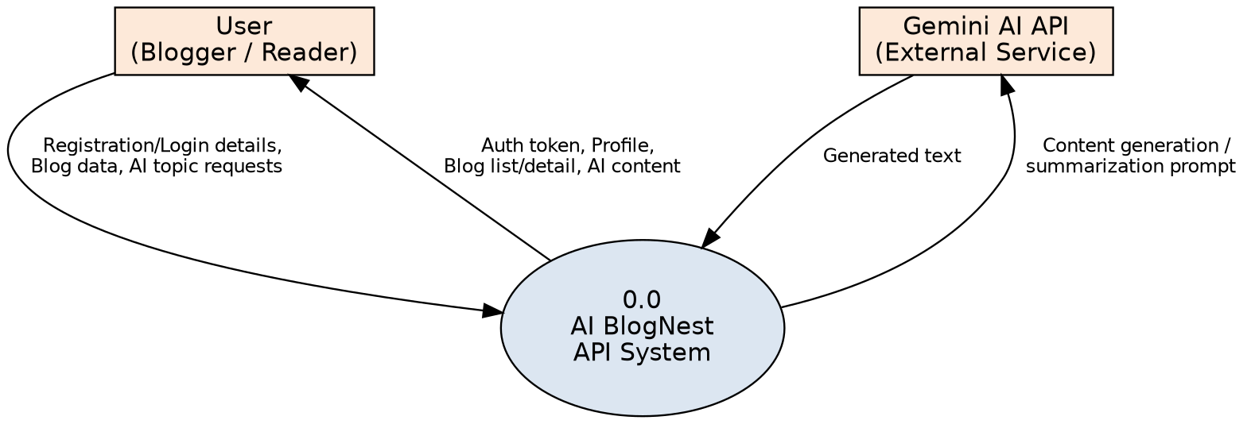
Figure 1: Level 0 (Context) DFD — BlogNest System
Level 1 DFD (Detailed Process Diagram)
The Level 1 DFD breaks down the main internal processes of BlogNest — Authentication, Blog Management, and AI Content Generation — along with the corresponding data stores, D1: Users and D2: Blogs.
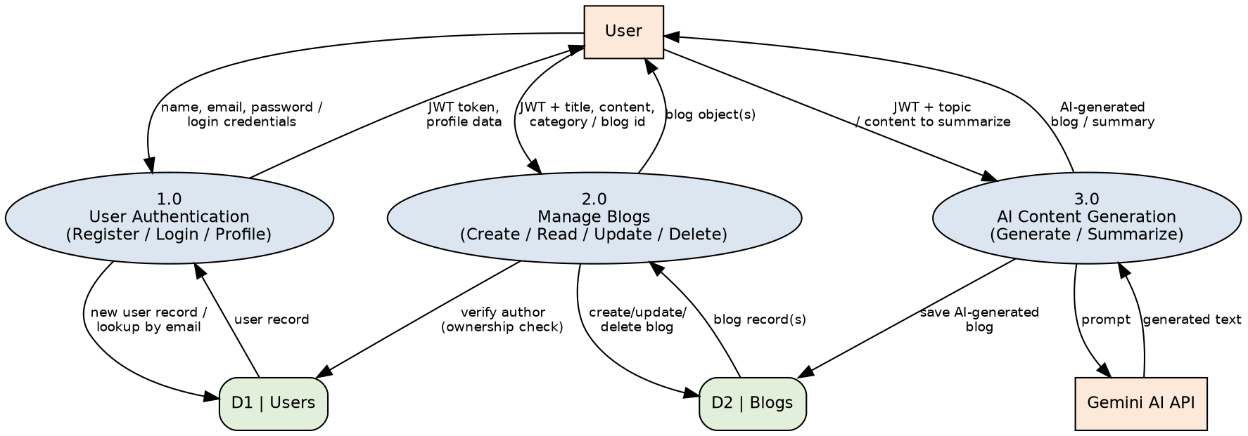
Figure 2: Level 1 DFD — BlogNest Processes and Data Stores
Data Flow Breakdown
- User Request → Process 1.0 (Authenticate User): the user provides registration or login credentials (name, email, password). The process validates them, updates the D1: Users data store, and returns a JWT token.
- User Request → Process 2.0 (Blog Management): the user sends requests to create, read, update, or delete blog posts along with the JWT token. The process verifies authorization against D1: Users and reads/writes the D2: Blogs data store.
- User Request → Process 3.0 (AI Generation): the user provides a topic. The process calls the external Gemini AI API, receives the generated text, and either returns it directly or saves it as a new blog post.
2. User Stories
User Type | Functional Requirement (Epic) | User Story Number | User Story / Task | Acceptance Criteria | Priority | Release
Customer (Web / Mobile) | Authentication | USN-1 | As a user, I can register for an account using my name, email, and password. | A new user record is created in MongoDB with a bcrypt-hashed password, and a 201 status code with the user's id, name, and email is returned. | High | Sprint-1
Customer (Web / Mobile) | Authentication | USN-2 | As a user, I can log into the application with my registered email and password. | Valid credentials return a signed JWT access token (7-day expiry); invalid credentials return a 401 'Invalid credentials' error. | High | Sprint-1
Customer (Web / Mobile) | Authentication | USN-3 | As a user, I can view my logged-in profile information. | Profile details (id, name, email) are returned when accessing the protected /api/auth/profile endpoint with a valid JWT; a 401 error is returned if the token is missing or invalid. | Medium | Sprint-1
Customer / Author | Blog Management | USN-4 | As an author, I can create a new blog post with a title, content, and category. | The blog post is saved to the database, linked to the authenticated user's id and name; missing title, content, or category returns a 422 validation error. | High | Sprint-1
Customer / Reader | Blog Management | USN-5 | As a user, I can view all published blog posts. | Returns the full list of blog posts, newest first, populated with the author's name and email. | High | Sprint-1
Customer / Reader | Blog Management | USN-6 | As a user, I can view a single blog post by its ID. | Returns the full blog post details, or a 404 error if the blog does not exist. | High | Sprint-1
Customer / Author | Blog Management | USN-7 | As an author, I can update my existing blog posts. | The post is updated successfully only if the authenticated user is the post's author; other users receive a 403 'not allowed to edit' error. | High | Sprint-2
Customer / Author | Blog Management | USN-8 | As an author, I can delete my own blog post. | The post is removed from the database only if the authenticated user is the original author; other users receive a 403 error and the post is unaffected. | Medium | Sprint-2
Customer / Author | AI Assistance | USN-9 | As an author, I can generate blog content using AI by providing just a topic. | The system sends a prompt to the Gemini AI service, saves a 100-150 word blog titled 'Guide to <topic>' with an auto-detected or supplied category, and returns the saved blog to the client. | High | Sprint-2
Customer / Author | AI Assistance | USN-10 | As an author, I can get an AI-generated summary of any blog content I provide. | The system sends the content to the Gemini AI service and returns a short, easy-to-read summary paragraph. | Medium | Sprint-2
Administrator | User & Content Governance | USN-11 | As an administrator, I rely on the application's security middleware to protect all sensitive resources. | Requests without a valid JWT, or with an invalid/expired Authorization header, are blocked with a 401 response before reaching any protected controller. | High | Sprint-1

